Media Compression and Distribution UG3

Tutorial: Revision – Signals, Transmission 2

Q1
List four causes of noise in an electrical system
How is noise measured?
Compare white noise with pink noise.

SOLUTION
Causes within the electronics of a system:
- Shot noise
- Thermal noise (Johnson–Nyquist noise)
- Flicker noise
- Burst noise; impulse noise (“popcorn noise”)

Other causes from "external" sources:
- interference
- contact noise
- avalanche noise
- partition noise
- grain noise

Q2
Discuss the relationship between noise and dynamic range in a camera sensor

SOLUTION
The sensor, as an active electronic system (i.e. includes amplifying gain circuits) introduce noise from the semiconductors involved in the sensor control circuits. Each photo-site (sub-pixel in the sensor) requires this control to measure the charge induced during the exposure; then to record the result in the rom/column matrix; apply any processing (exposure gain, colour balance, etc).
The sensor is compromised by the small space available, so electronics may interfere across the sensor (i.e. from one photo-site to the next, etc).
Each site has a capacity to record the charge. The more noise in the system will use more of this capacity. So noise will result in variations of charge; each incidence of noise will add or subtract a noise voltage to affect the charge. This is more prominent in the lower charge pixels, i.e. the darker pixels. So noise compromises the darker parts of the image.

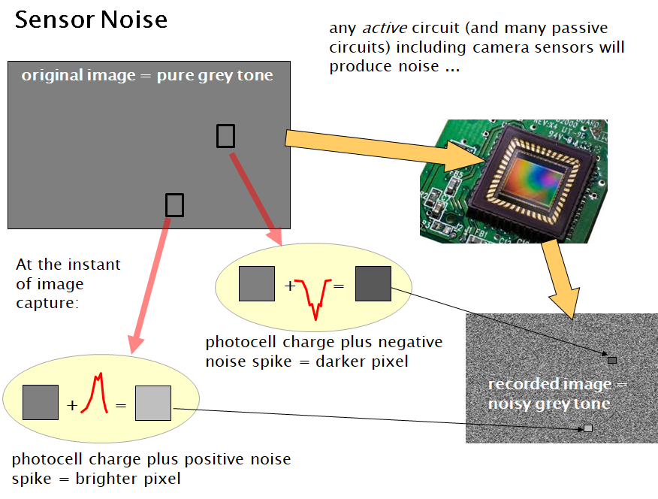

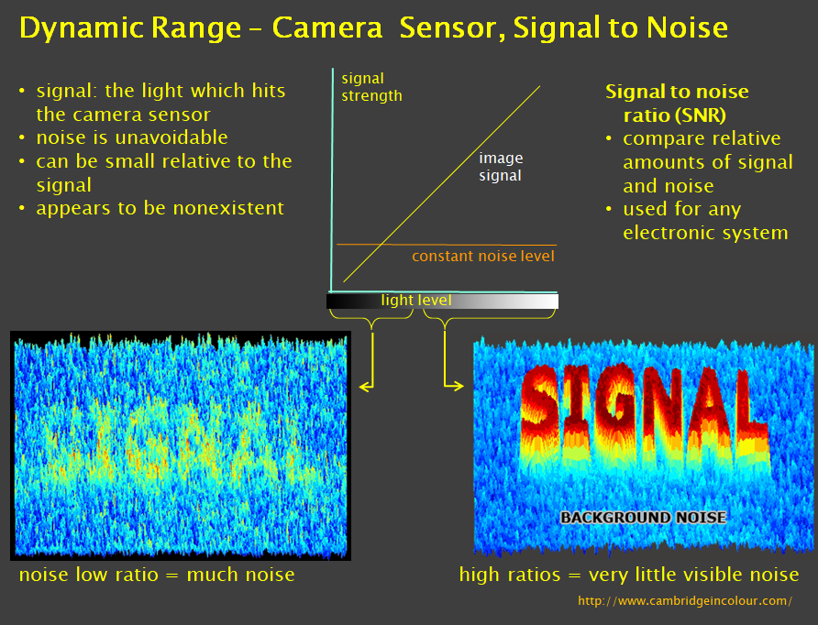
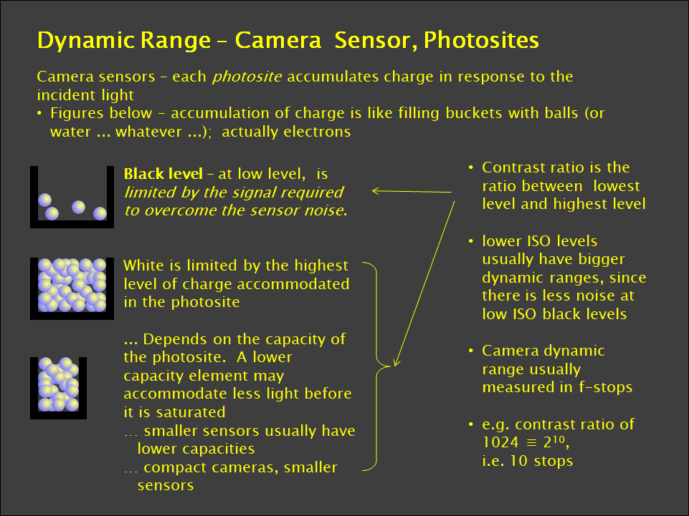
Dynamic range is the usable range of a photo-site (and the whole sensor). So the more noise in the system, the more the dynamic range is affected by the noise in the system, i.e. the increased noise reduces the dynamic range of the system.

Q3
Explain the occurrence of an alias signal in analogue -to- digital conversion

SOLUTION
Aliasing occurs when the sampling frequency is insufficient to resolve the frequencies (i.e. the highest frequency) in the sampled audio.
At the highest frequency the signal needs to be sampled at least twice per period to sufficiently record that frequency.
So the Nyquist Theorem states that:
Sampling frequency should be at least twice as high as the highest frequency being encoded. The highest frequency is the Nyquist Frequency
If the sampling is not sufficient ten an alias signal is produced from the inaccurate samples. The alias signal produced will be lower than the original (intended) signal.
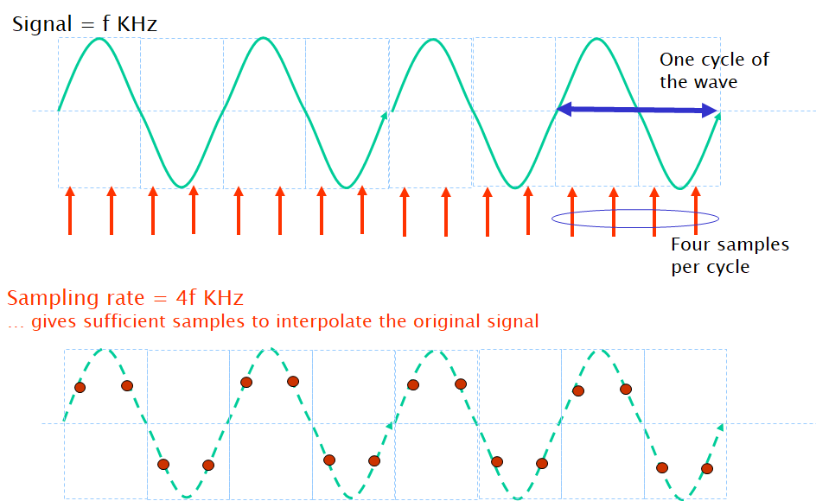

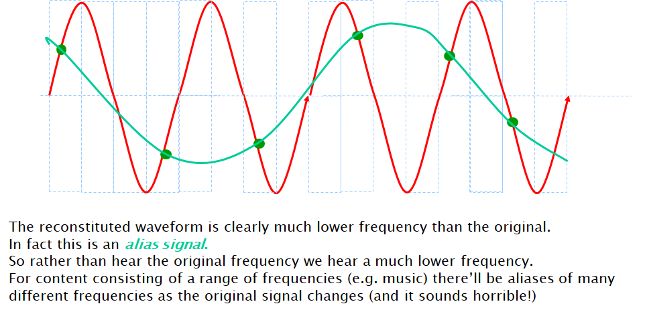

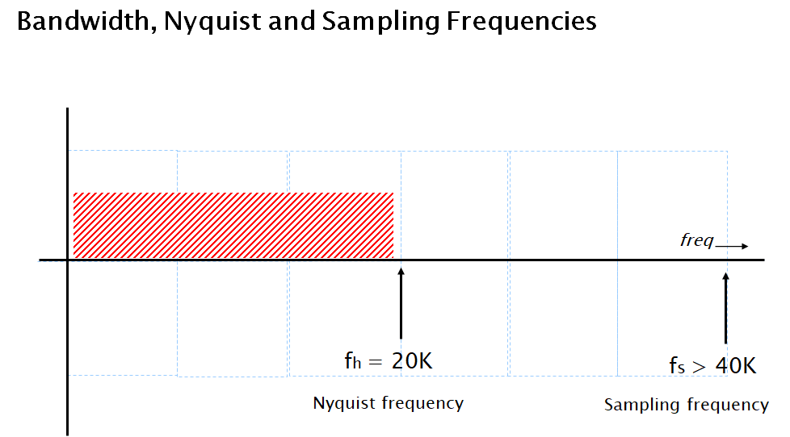

Q4
The main transmission media for conveying signals is cable, radio/satellite and optical fibre. For each of these media, consider the relative advantages and disadvantages of the media, the transmission issues that can cause signal errors, and what can be done to overcome these issues.

SOLUTION

Twisted Pair Cable
Advantages:
- High availability
- Low installation cost

Disadvantages:
- Usable frequency spectrum is small
- Limited data rates
- Limited range
- High susceptibility to electromagnetic and radio frequency interference

Issue: cable can be affected by common mode interference, so twists assist in rejecting this interference
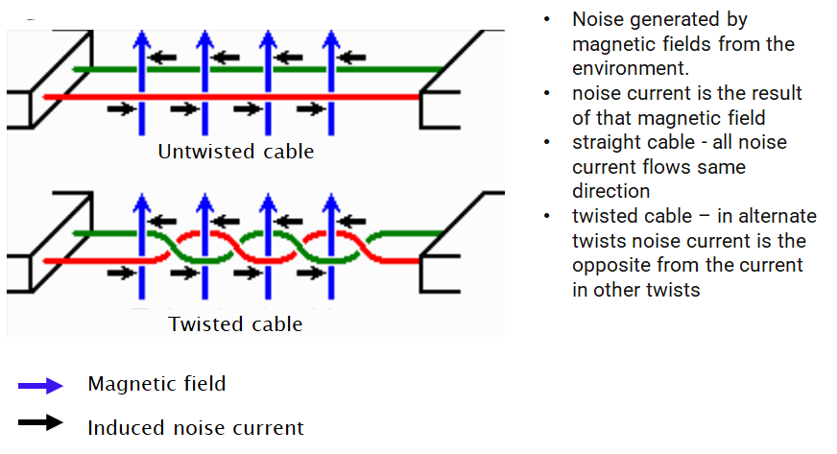

Coaxial Cable
Advantages:
- High capacity (370-1000 times more than twisted pair)
- Low susceptibility to noise and crosstalk (because of shielding)

Disadvantages:
- Noise on the return path
- High installation cost

Electric and magnetic fields are confined to the dielectric with little leakage outside the shield
Electric and magnetic fields outside the cable are largely kept from causing interference to signals inside the cable

Fibre Optic Cable
Advantages:
- Low cost
- High capacity
- Thin
- Low interference/degradation

Disadvantages:
- Has a minimum radius for bending
  - Requires fibre to maintain sufficiently low bending to maintain total internal reflection for transmission
- Each fiber is one-way
- High cost of interfaces
  - Opto-electronics interfacing for conversion between fibre and cable circuits
  - Labour resources to install fibre and interfaces

Multipath transmission within the fibre can occur resulting in a smearing of the signal received. Graded index fibre can overcome this by allowing direct rays to travel in the centre of the fibre (with a higher refractive index, therefore slower; rays travelling the more circuitous routes will take the outer parts of the fibre which are lower refractive index, therefore faster. This assists the rays to arrive in a more synchronous manner at the receiver.

Radio Transmission

Often restricted to line of sight, or ground wave transmission or reflection (actually refraction) from layers of the earth’s atmosphere.
Installation requires expensive transmission/reception equipment, but avoids laying ducts of cables or fibres.

Q5
Compare and contrast the principles of circuit switched data with packet data.
Compare the relative merits of each in terms of efficiency, economy and security, and the suitability of both methods for media distribution.

SOLUTION

Circuit switched allows the full transmission bandwidth of the circuit to be allocated to the session. This is expensive considering that transmissions often include long periods of no data. Consequently packet systems allow a number of sessions to occupy the transmission media as “statistically multiplexed” sessions. This requires each session’s data to be packetized and therefore the processing each packet requires buffering, examination of addressing, directing to the required output port, and queuing for an appropriate availability in the outgoing route.

Q6
Explain the relationship of the internet and the WWW.
Describe the function of network routers, and compare with the simpler Ethernet hub.
State the relationship between a MAC address and an IP address.

SOLUTION
The internet is the infrastructure of routers and transmission paths.
The web is an overlay of servers to support higher level services.
The MAC (Media Access Control) is associated with each individual device attached to the network. The IP (Internet Protocol) address is a temporary address assigned as the device initiates attachment on the network. MAC and IP addresses are related through the ARP (Address Resolution Protocol) table as the IP address is assigned (typically via DHCP (Dynamic Host Configuration Protocol).

Q7
Describe the function of network servers.
Give examples of different types of servers, i.e. the type of information they serve.
Explain the term “User Client” and give examples of clients and the relationship between a client and server,

SOLUTION
Servers maintain a set of data for access by users of the network (typically the WWW)
There are a range of types of servers – HTTP web servers; email (POP, SMTP, etc) servers, RADIUS servers, etc.

